1. Five common BIOS or POST error messages
BIOS (Basic Input/Output System) is firmware that initializes and checks the computer's hardware when the PC is switched on. POST (Power-On Self-Test) is the diagnostic process performed by the BIOS before the operating system starts.

No. | BIOS/POST error message | Possible hardware or configuration issue
1 | CMOS Checksum Error – Defaults Loaded | The CMOS battery may be weak or dead, or the stored BIOS settings may be corrupted.
2 | Keyboard Error or Keyboard Not Detected | The keyboard may be disconnected, faulty, or connected to a damaged USB or PS/2 port.
3 | Hard Disk Not Detected | The hard drive or SSD may be disconnected, faulty, or incorrectly configured in BIOS.
4 | Memory Test Failure | The RAM may be faulty, improperly seated, incompatible, or incorrectly configured.
5 | CPU Fan Error | The CPU cooling fan may be disconnected, damaged, running too slowly, or not detected by the motherboard.

2. Scenario: PC beeps three times repeatedly and displays nothing

Two troubleshooting steps
Step 1: Reseat and check the RAM modules
- Switch off the computer and disconnect its power supply.
- Open the computer cabinet.
- Carefully remove the RAM modules.
- Check for dust or dirt on the RAM contacts and slots.
- Reinsert the RAM modules firmly into their slots.
- Start the computer and check whether it boots normally.
Step 2: Test the RAM modules individually
- Remove all RAM modules except one.
- Try starting the computer with one RAM module at a time.
- Test the modules in different compatible memory slots.
- Identify whether a particular RAM module or motherboard slot is causing the problem.
- Replace faulty RAM if necessary.

3. Accessing BIOS Setup Utility and identifying motherboard information
Procedure
- Switch on or restart the computer.
- Immediately press the BIOS setup key repeatedly during startup. Common keys include:
  - DEL (Delete)
  - F2
  - F10
  - ESC
- Wait for the BIOS setup utility to appear.
- Open the Main, System Information, or BIOS Information tab.
- Locate the motherboard manufacturer, motherboard model, BIOS manufacturer, and BIOS version.
- Take a screenshot of the main BIOS screen for your assignment.
- Press ESC to exit, or select Exit Without Saving if no changes were made.
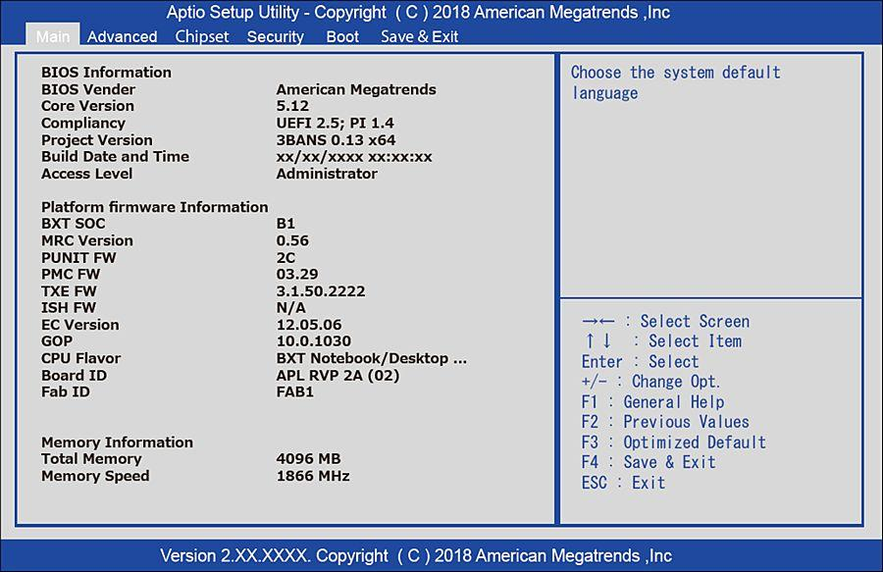

s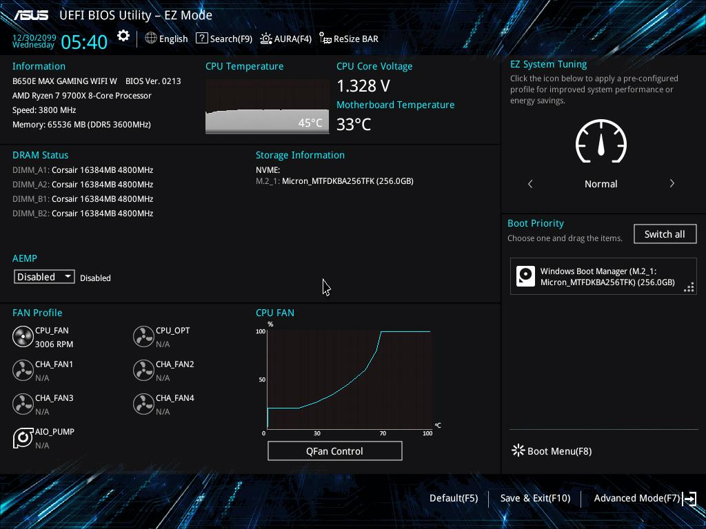

4. CMOS Checksum Error – Defaults Loaded

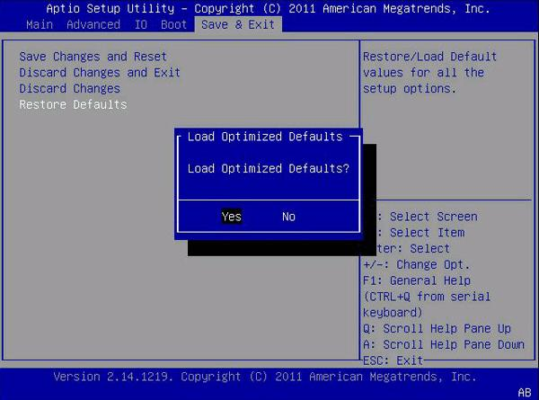
The message "CMOS checksum error – Defaults loaded" indicates that the BIOS has detected that the stored CMOS configuration data is incorrect, corrupted, or does not match the expected checksum.
CMOS (Complementary Metal-Oxide-Semiconductor) memory stores important BIOS configuration settings, such as:
- System date and time.
- Boot device priority.
- Hardware configuration.
- Storage configuration.
- Other motherboard settings.

- Steps to resolve the issue

Step 1: Replace the CMOS battery
- Turn off the computer.
- Disconnect the power cable.
- Open the computer cabinet.
- Locate the round CMOS coin-cell battery on the motherboard.
- Carefully remove the old battery.
- Install a new battery of the correct type, usually CR2032, observing the correct polarity.
- Close the cabinet and reconnect the power.

Step 2: Reset and configure BIOS settings
- Switch on the computer.
- Press DEL or F2 to enter BIOS setup.
- Select Load Setup Defaults, Load Optimized Defaults, or the equivalent option.
- Set the correct date and time.
- Check the boot order and select the correct boot drive.
- Verify storage settings and other required configurations.
- Save the changes by pressing F10 or selecting Save & Exit.

Step 3: Restart and verify
- Restart the computer.
- Check whether the CMOS checksum error appears again.
- Verify that the date and time are retained after shutting down and restarting.
- If the error continues even after replacing the battery and restoring settings, inspect the motherboard or seek professional assistance.

